**Tutorial for Oyster Activity Detection System**

By: Ashley Afueh & Shanice Nurse

Table of Contents

**Overview/Hardware Setup3**

**Software Setup4-5**

**Picture Taking System Setup5-9**

**Image Processing System Setup10-13**

**How to Erase Data and Restart Program** **14**

**How to Read Data on Website15-18**

**Hardware Setup:**

Hardware Components (or materials):

1. Logitech C270 webcam Camera
2. Raspberry Pi 4
3. Keyboard with USB cable
4. Mini HDMI to HDMI chord
5. USB-C charger cable
6. Mouse with USB Cable
7. Monitor with USB Cable and HDMI port
8. Outlet with 2 open sources available
9. Duct tape

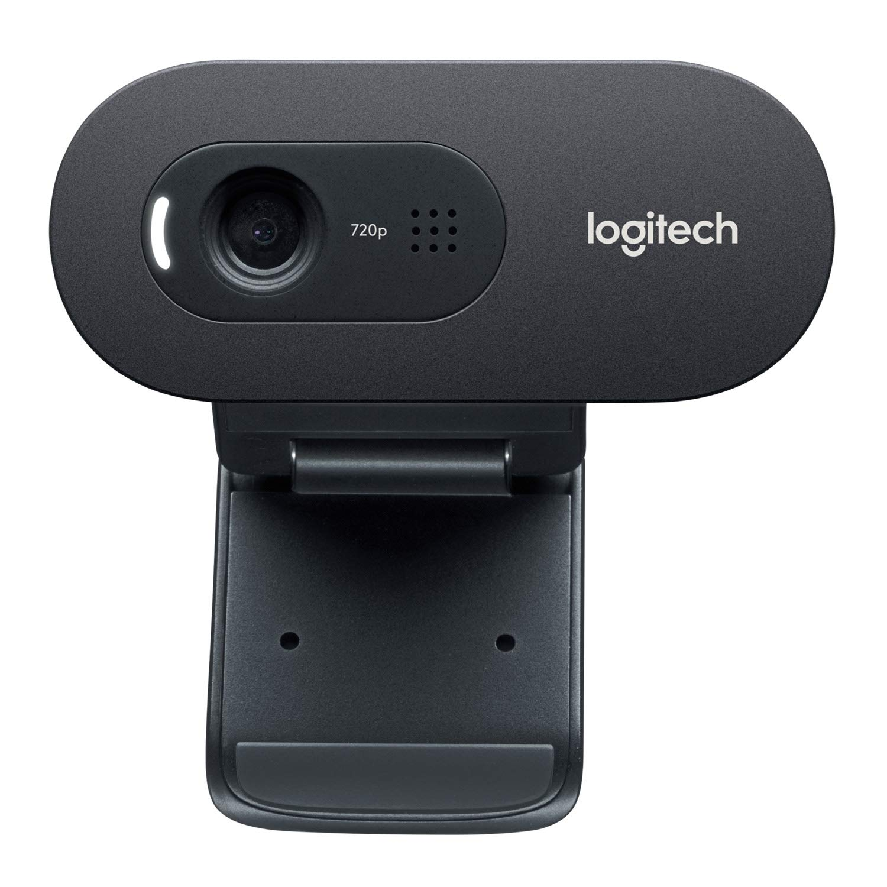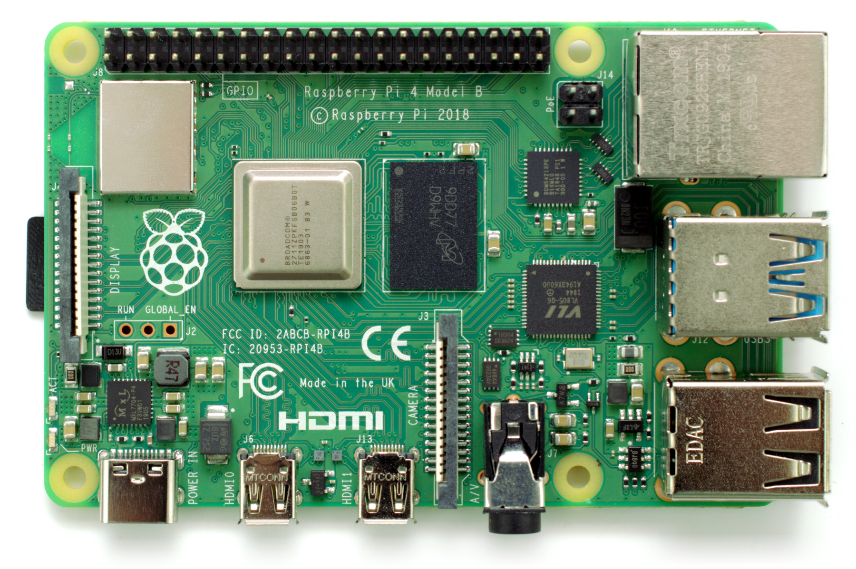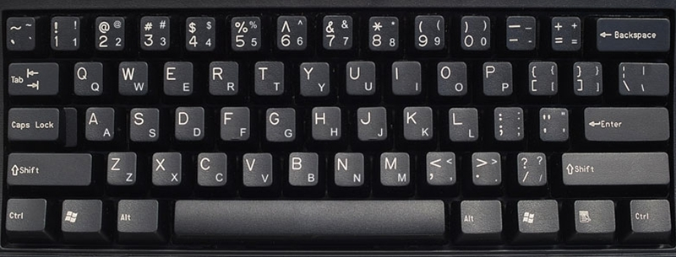

1. (2) (3)

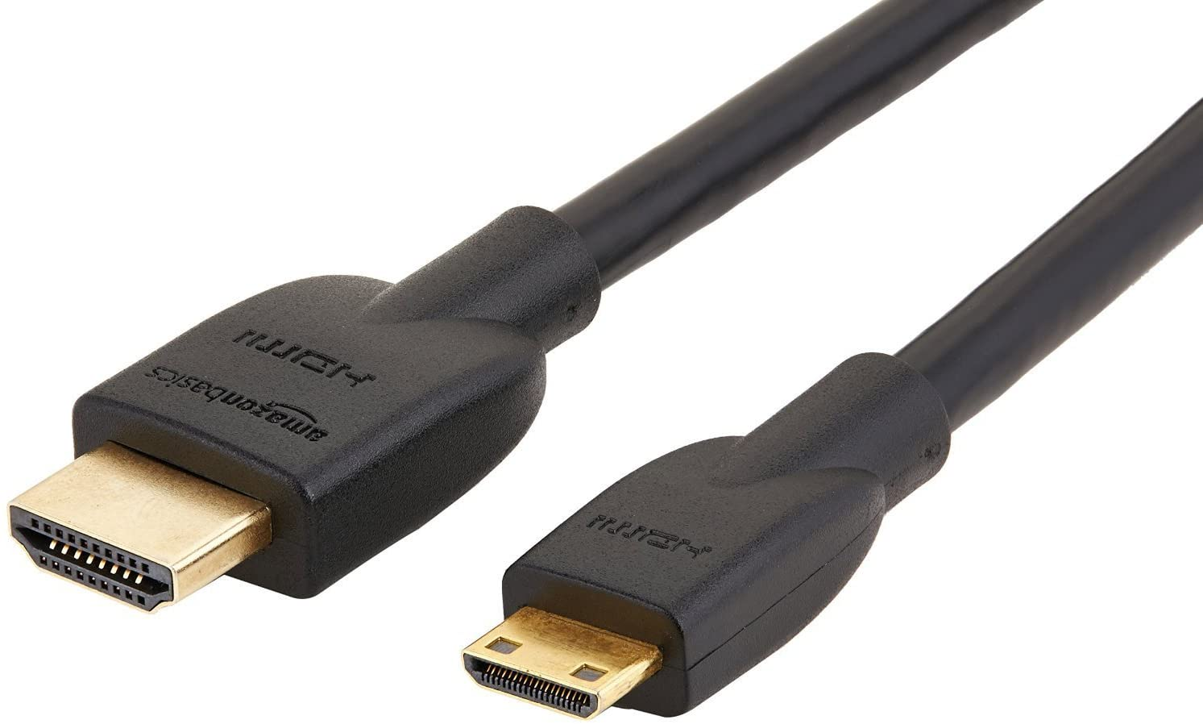 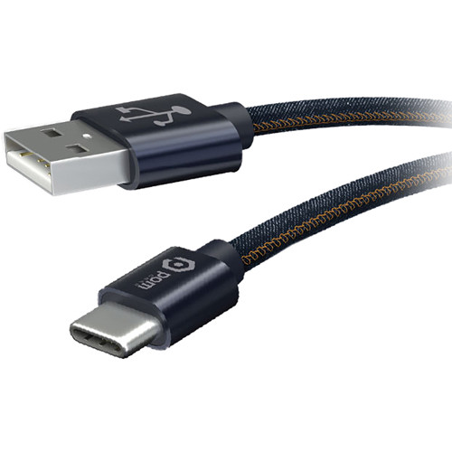 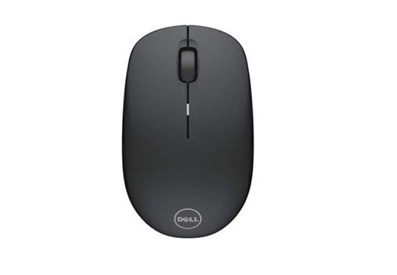

(4) (5) (6)

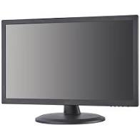 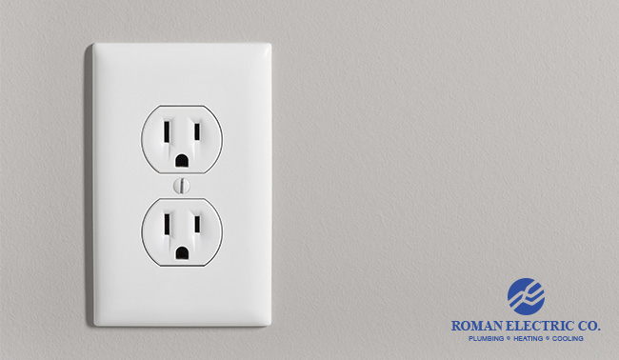 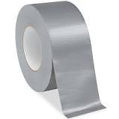

(7) (8) (9)

**Overview:**

The Oyster Activity Detection System determines the level of oyster activity in an aquatic tank. The following pages are a tutorial on how to work this system.

**Software Setup: Part 1**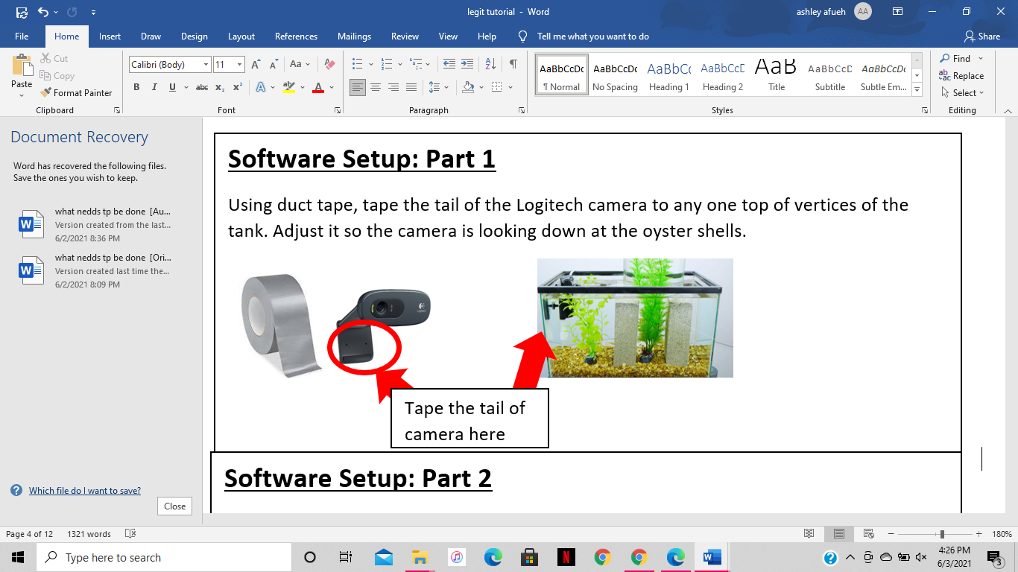

**Software Setup: Part 2**

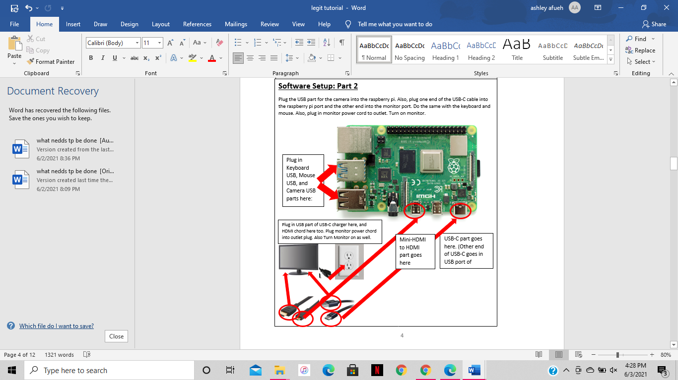

new folder

**Picture Taking System Setup:**

Click the “file” button and go to pi>Pictures. Here, create a folder and name the folder “oysters”, as shown below.

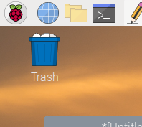

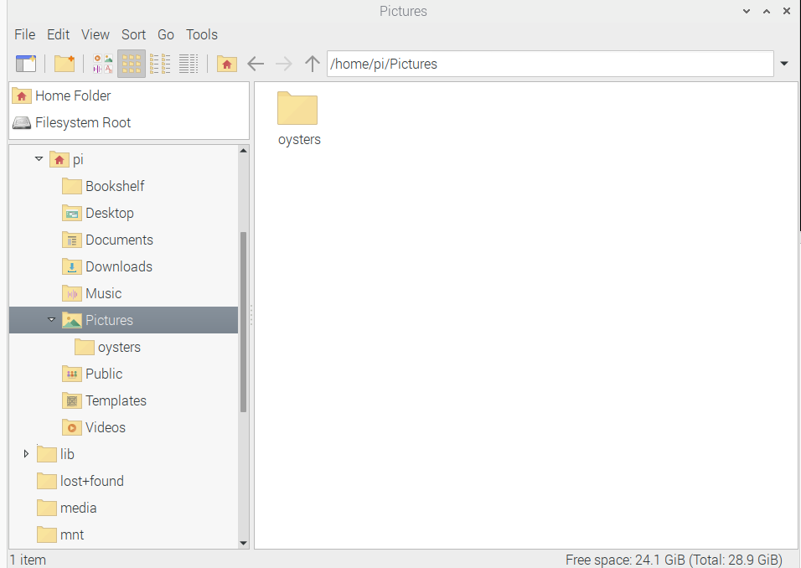

**Software Setup: Part 4:**

Now that your raspberry pi operating system is setup, you can now access the internet on the system. Click on the 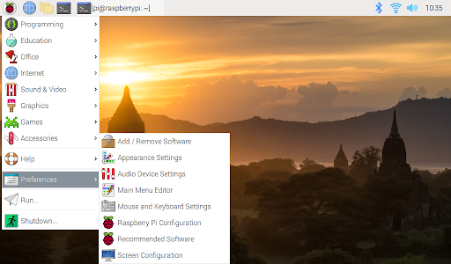 icon and then scroll over “internet”. From there another list of items should pop up. Click “duckduckgo” and then an internet browser will pop up.



1

2

3

“DuckDuckGoo” should pop up here, click that

**Software Setup: Part 3:**

Go to the following website to setup your raspberry pi operating system: <https://projects.raspberrypi.org/en/projects/raspberry-pi-setting-up>

Open file



1

2

3

“DuckDuckGoo” should pop up here, click that

Open the command tab on your raspberry pi software.



This should pop up. This is called the command box.

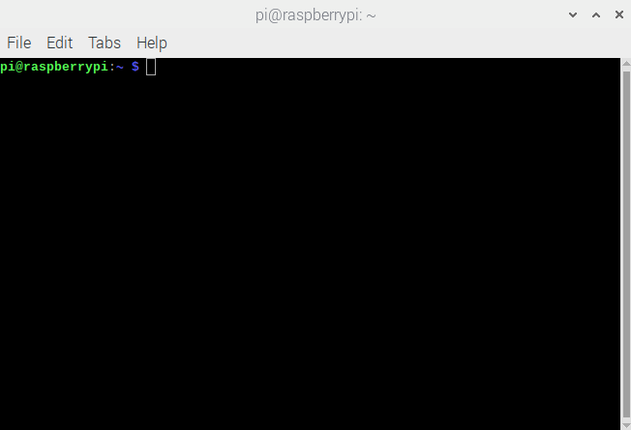

Type in the command ‘install sudo apt-get install fswebcam’ then click enter. This will install your webcam.

Next, type in the command ‘sudo apt-get install motion’ and then click enter. This will install the system needed to install the program needed to take pictures periodically.

Next, type in ‘lsusb’ and click enter. You should see a list of all of the devices connected to the raspberry pi. Be sure to ensure that the camera is listed here. If it is not, try to install the webcam again by typing in the command ‘sudo apy-get install fswebcam’.

Next, type in the command ‘sudo nano /etc/motion/motion.conf’

This will open up the configuration tool for the timelapse motion system, seen below.

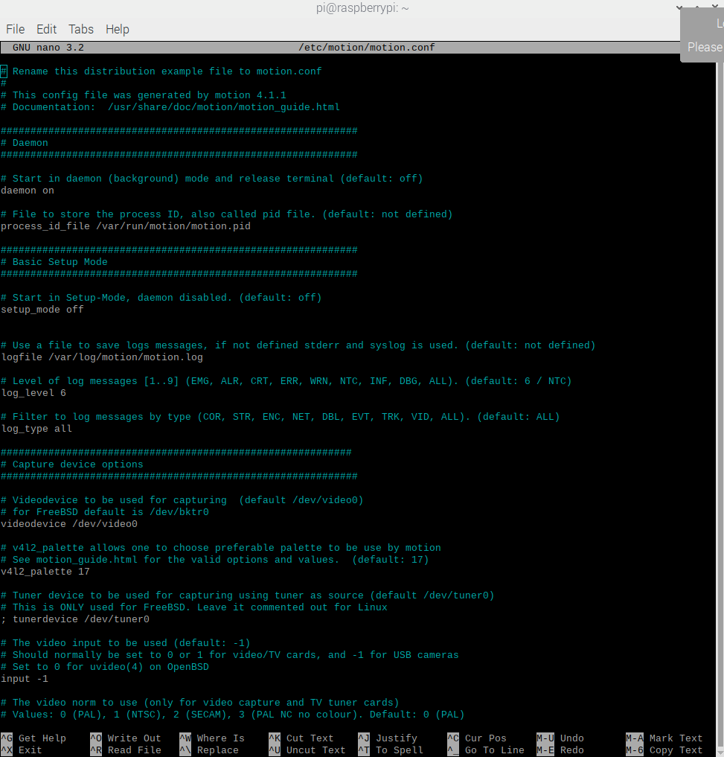

Green light is on



There are some adjustments that must be made in this configuration tool before we can start the system.

Since the configuration tool includes such a long list, we will navigate around using the “cntl + w” keys to search for what we are looking for within the configuration.

Change the following parameters:

1. Make sure **'daemon'** is **ON**.
2. Set '**framerate**' anywhere in between **1000 to 1500.**
3. '**Stream_quality**' should be **100**.
4. Change '**Stream_localhost**' to **OFF**.
5. Change '**webcontrol_localhost**' to **OFF**.
6. Set '**quality**' to **100**.
7. Set '**width**' & '**height**' to **1280** & **720**.
8. Set '**Snapshot_interval'**equal to **10**. (***every 10 seconds 1 photo will be taken*** )
9. Set '**target_dir**' as the path in the folder of where the oysters are, which is /home/pi/Pictures/Oysters (this is what you type in, instead of the path that is already there)
10. Press **ctrl + x** to exit. Type **y** to save and **enter** to conform.

Again, type in the command '**sudo nano /etc/default/motion** ' and press enter. Then, set ' **start_motion_daemon** ' to **yes**. Save and exit.

Next, restart the system by typing ‘sudo motion service restart’. This way, we can get the system nice and refreshed in order to start the system.

Next, type ‘sudo motion’ and press enter. This will start your system. You should see your camera’s green light turn on.

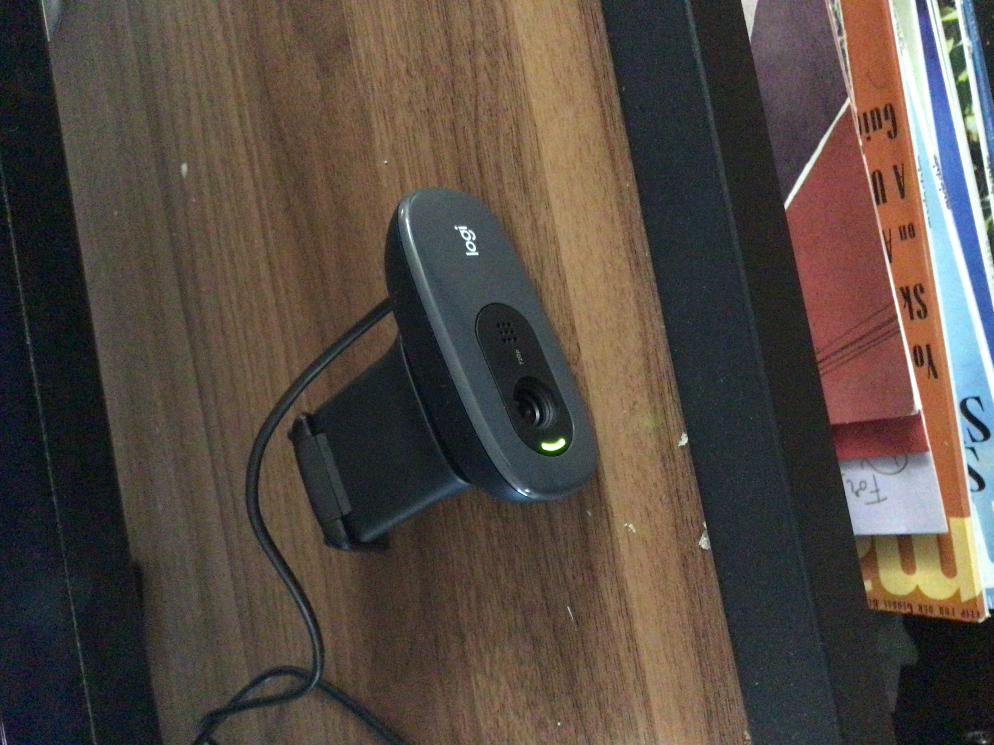

In order to stop the system, type ‘sudo service motion restart’ in the command box. You should see the green light in your camera turn off.

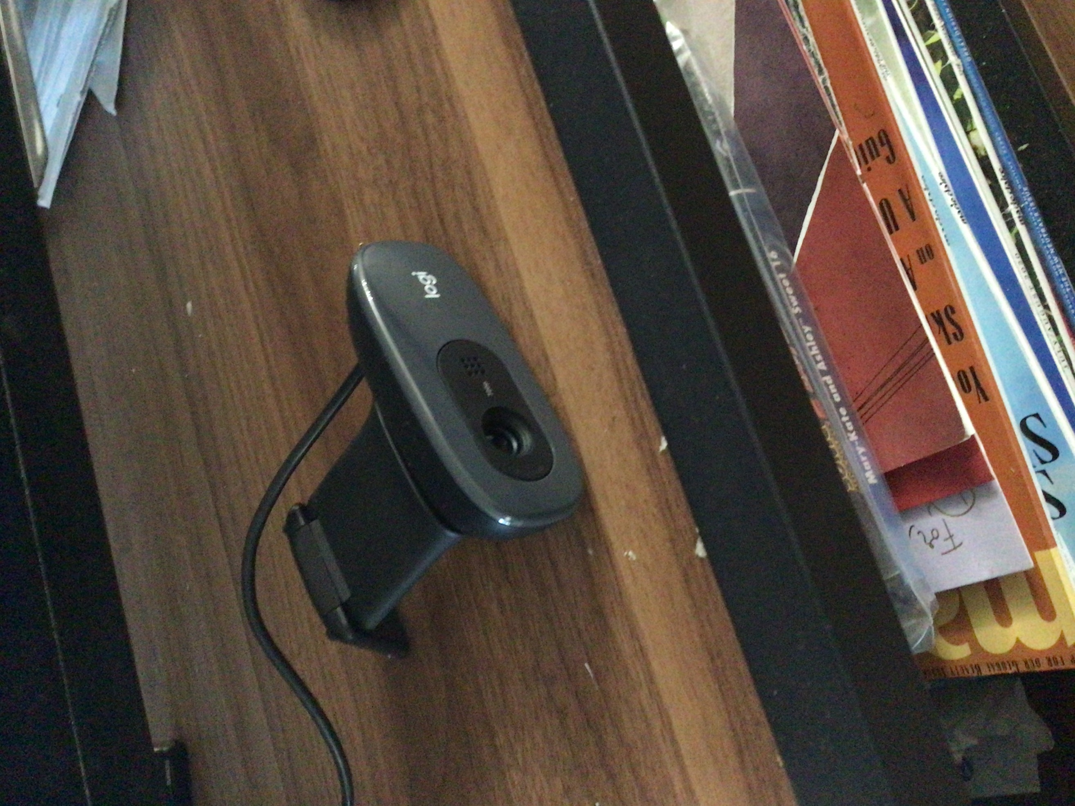

Also, in order to change the interval that the camera takes a picture, you can changer parameter #8 on the list above. You can do this by going back to the configuration page. Type ‘sudo nano /etc/motion/motion.conf’ in the command box Remember, you can use ‘**cntrl + w**’ in order to navigate throughout the entire configuration page. Changing '**Snapshot_interval'**to whatever interval you would like the pictures to be taken at, in seconds. (It MUST be in seconds. not minutes).

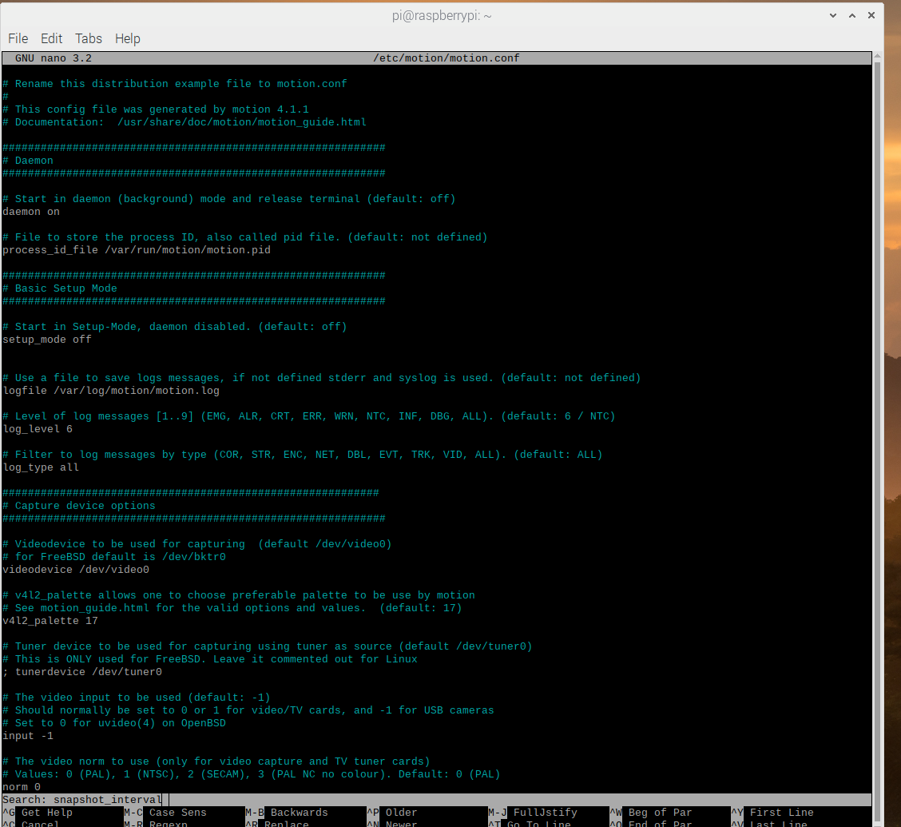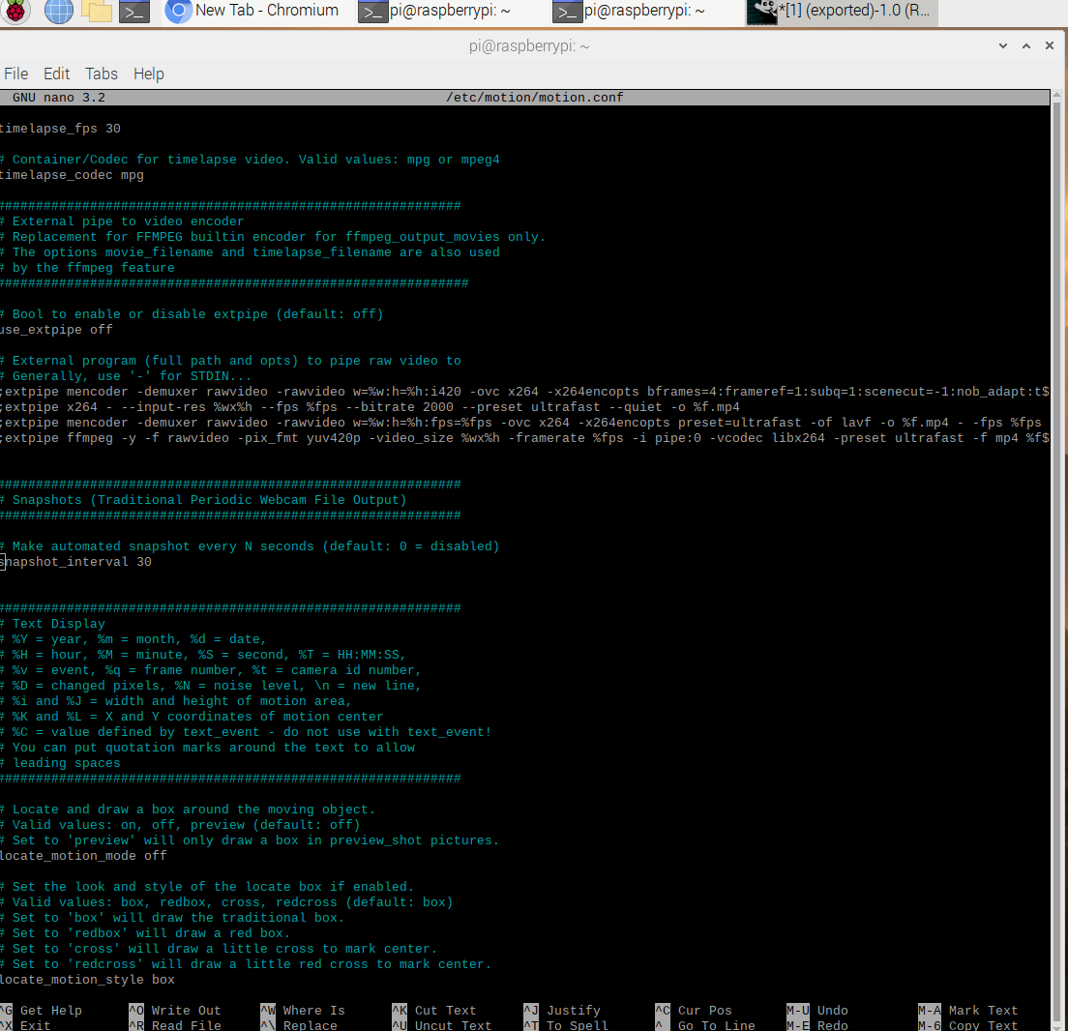

 

When your desired time to run the system has finished, turn off the system and go to the folder where all of the pictures are stored. Right click the folder and click “copy”. Then right click any blank space in the file box and click “paste”. This will create a new folder which is a copy of your oysters folder. We have to the new, copied folder to the name “data”. When the following box pops up, click “rename”, and make the new file name “data”.

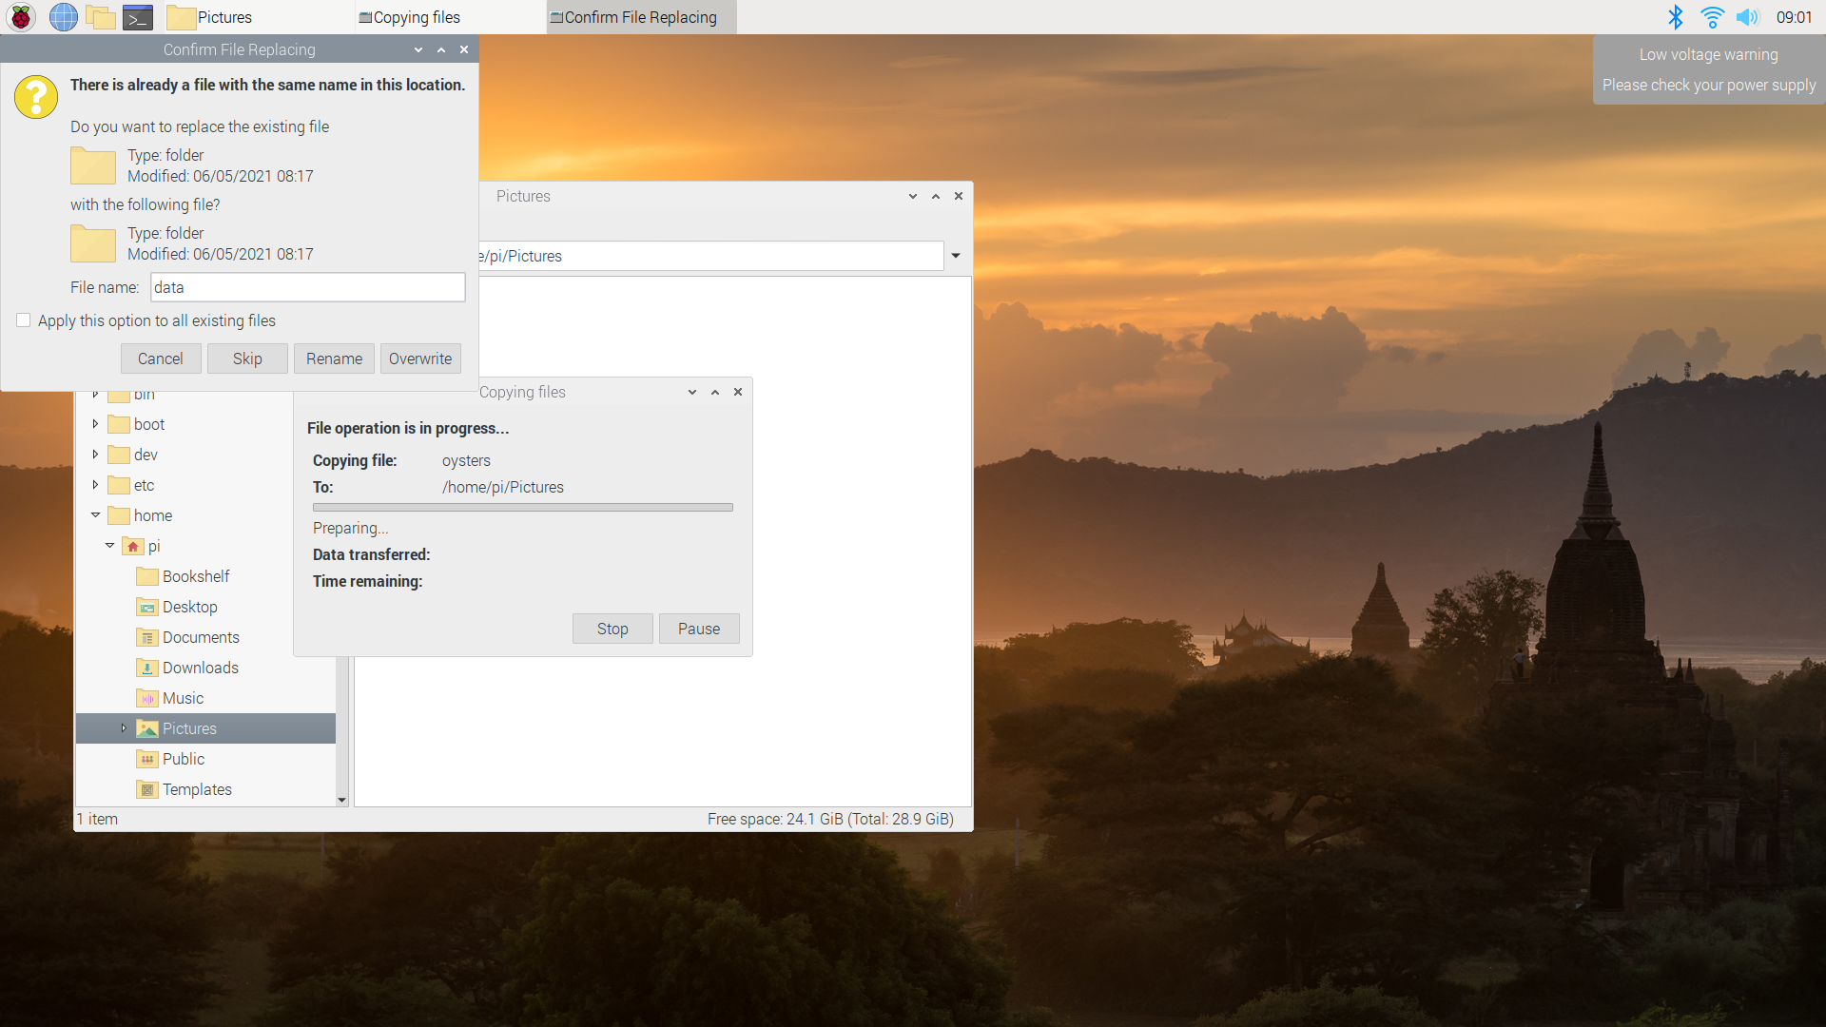

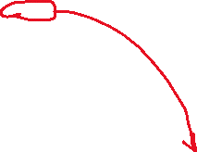

This folder must be compressed in order for it to be compatible with the program, so we must compress this folder. Let’s install a zip package in order to zip the folder. Open a command window, type ‘sudo apt-get install zip unzip’, then press enter. Then, right click on the folder “data” and select “compress”. Change the archive type to “zip”, then click “create”.

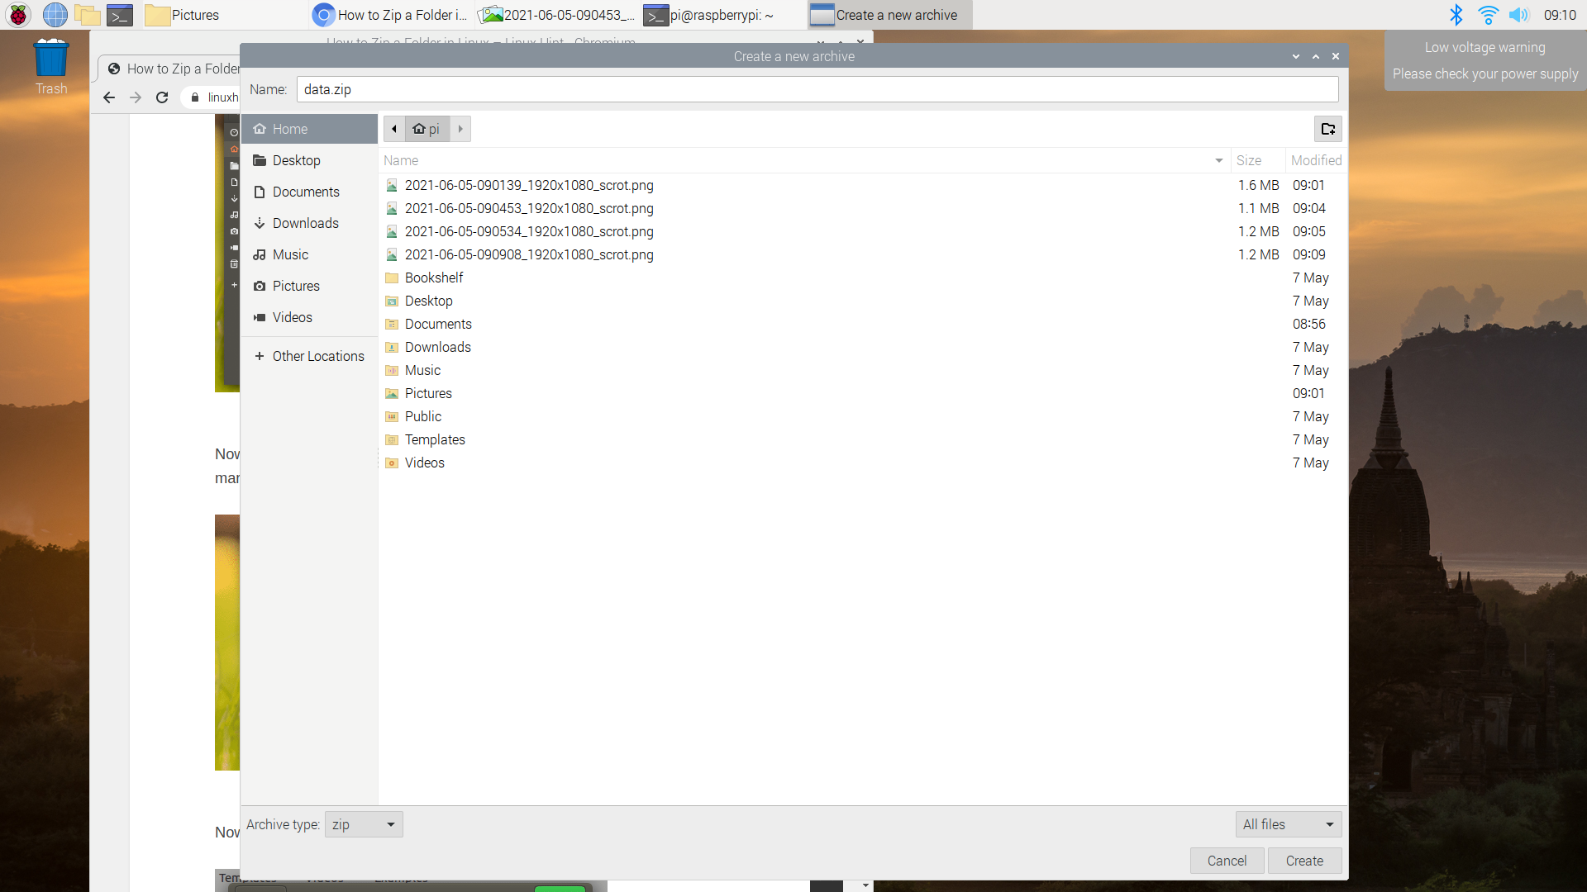

Then compress the folder by clicking “create”. A new zipped folder with the same name will be created in the same location, as shown below.

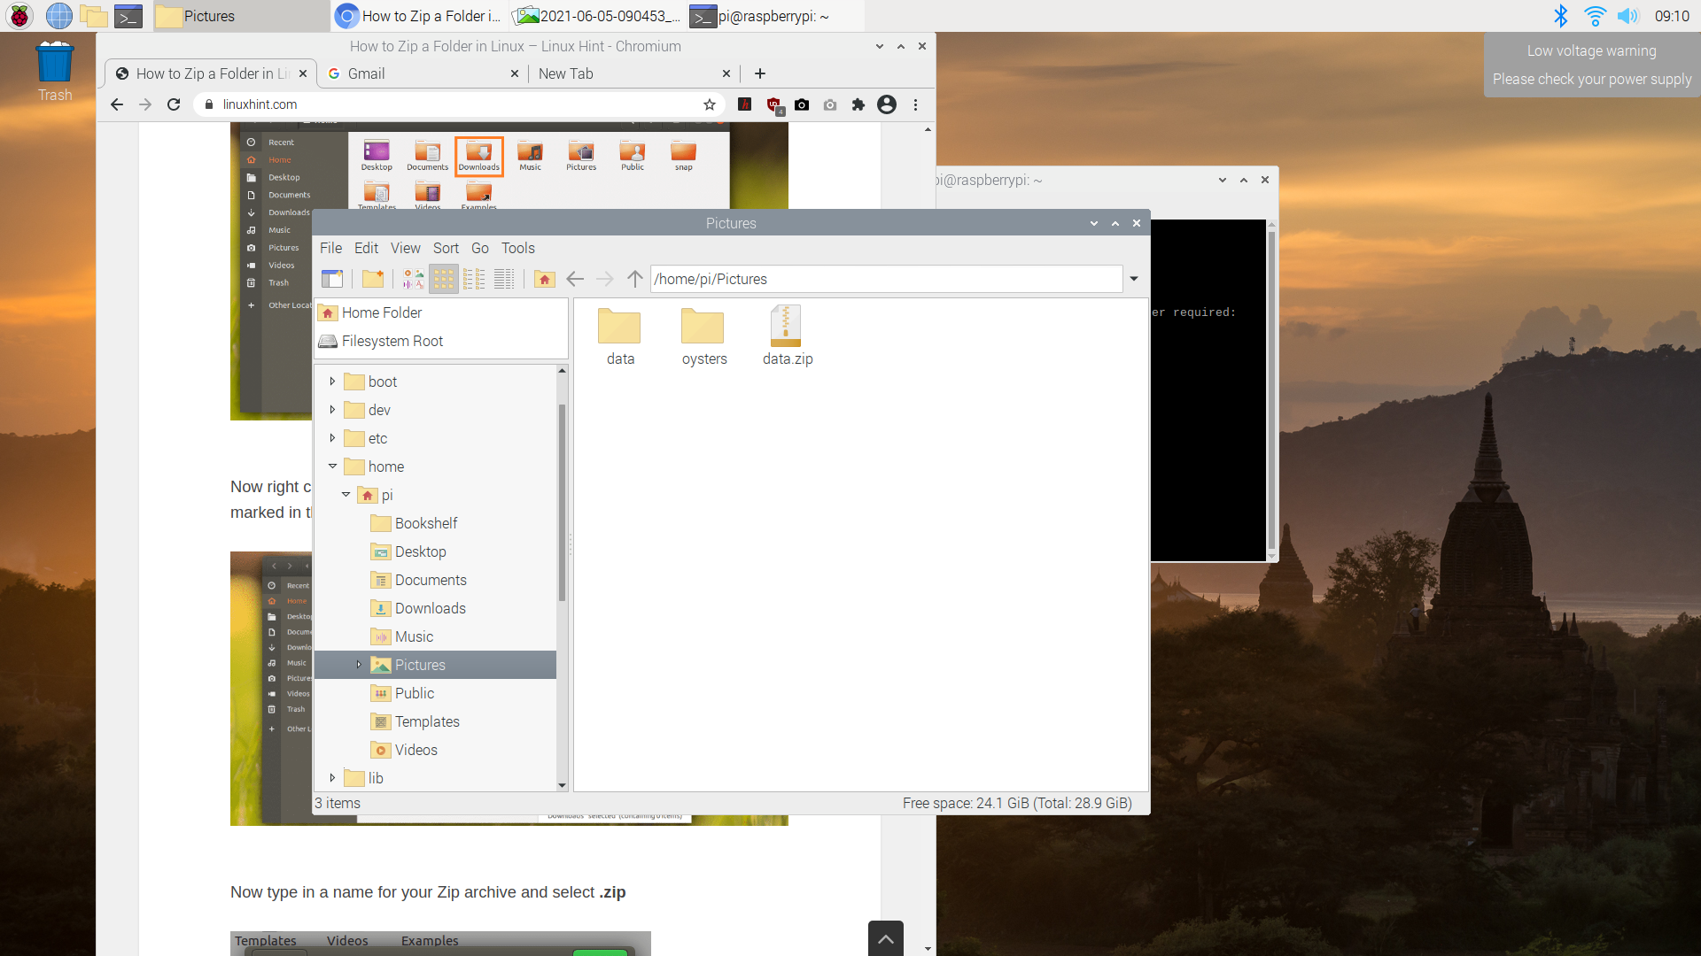

Now that we have our images in a zip file, it is time to process them.



**Image Processing System Setup:**

Now that we have all of the data, we can begin the image processing process. Click the following link and login with the username and password set below:

<https://colab.research.google.com/drive/1cBNMFgRmGsg0mN-36s8TYhtZSk-UzRPi?usp=sharing&hl=en>

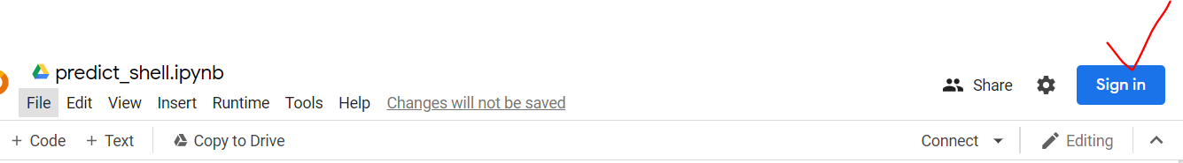

username: [oysterdetection2021@gmail.com](mailto:oysterdetection2021@gmail.com)

password: DetectOysters2021!

Under all of the tabs. hover over “Runtime” > “Change Hardware runtime” > and then choose “GPU” as the hardware accelerator. 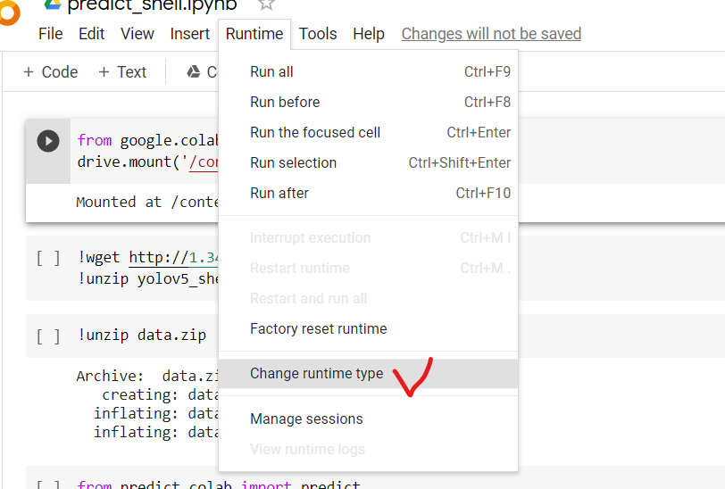

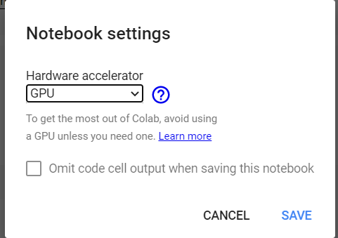

Click the “play” link in the first cell, and then click the link is written after the phrase “Go to this URL in a browser”.

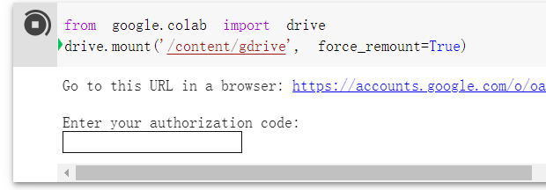

Then, connect to the [oysterdetection2021@gmail.com](mailto:oysterdetection2021@gmail.com) account in google drive.

Copy the text that is below this and enter it in the box that says “enter your authorization code”, and then click enter. When it is finished connecting, you should see the following image for the first cell:

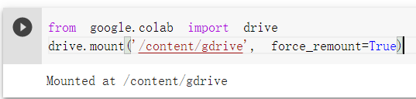

Next, click “play” on the next cell. This will activate the model.

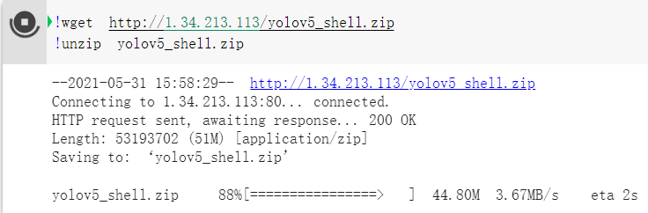

Next, click the next button on the next cell. This will tell the program where to save all of the data.



Now, click the last button on the last cell of this program. This will put all of the labeled pictures and numerical data to the google drive folders. 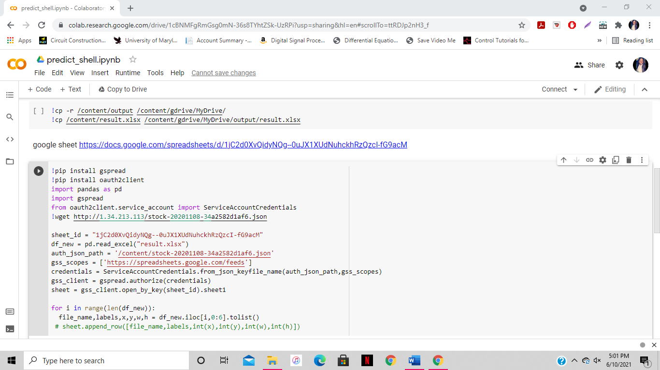

You can now open your google drive and then the archives of the numerical data and visual data will be there. Also, the website will reflect all of this data as well.

ERASE ALL OF THIS DATA

**How to Erase Data and Restart Program:**

Before you erase all of the data and restart the program, please note that the google drive folders and excel sheet update every time the program runs. Therefore, be sure to save any copies of the numerical data or visual picture data that you need, because after you run the program again, the old data from the previous trial will be gone.

First, in order to erase all of the data and start over, we will have to delete all the data that was collected in the last cycle. First, delete the “data” folder and “data.zip” file in your pictures folder.

Next, delete all of the images in your “oysters” folder as well. However, be sure to keep the “oysters” folder itself. The images inside of the “oysters” folder are what needs to be deleted.

Next, go to <https://docs.google.com/spreadsheets/d/1jC2d0XvQidyNQg--0uJX1XUdNuhckhRzQzcI-fG9acM/edit?usp=sharing> and delete all the data from column A2-F2 downwards to where the data ends.

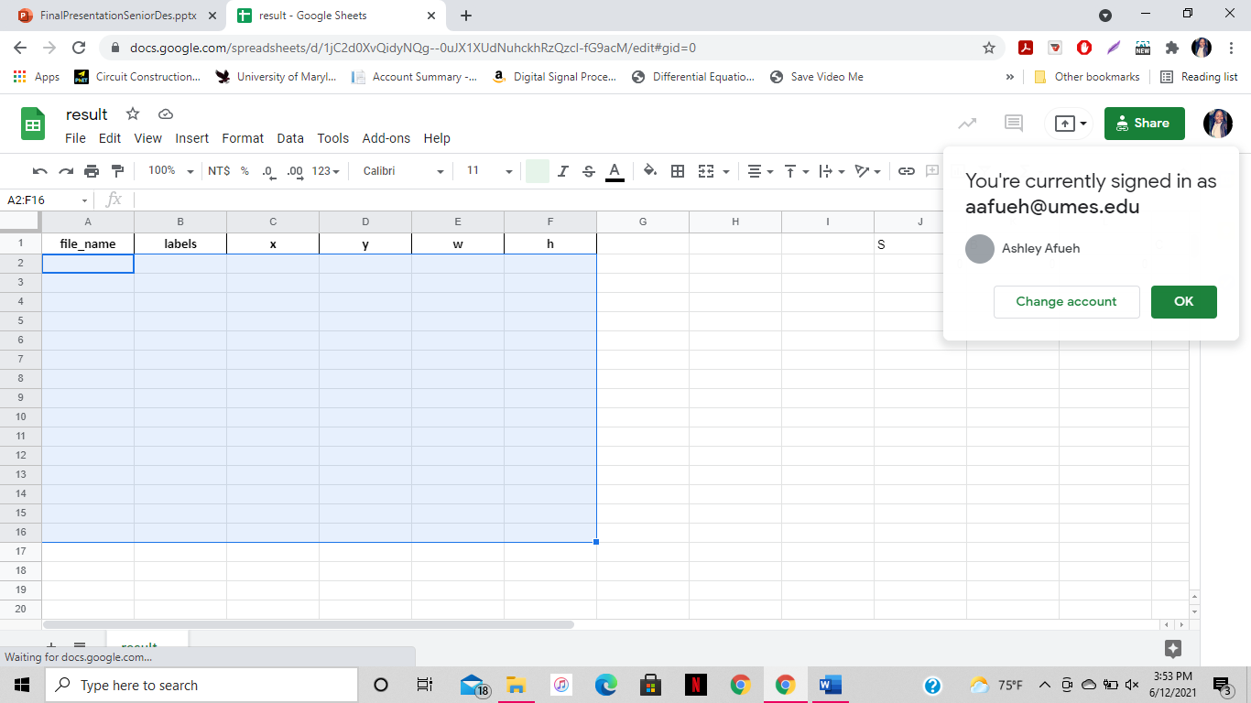

Lastly, go to the google collab page and hover over the “runtime” tab, then click “Factory Reset Runtime”.

To start over, after you have selected your desired snapshot interval as stated in the previous step, you can begin taking pictures by opening the command window and typing “sudo motion”. When it is finished running for the desired time, you can type “sudo motion service restart” to stop the program. Then, you can follow the above steps from changing the oyster file to a zip file in the “Picture Taking System Setup” step, all the way to the end of the “Image Processing System Setup” step. Also, you can skip any parts in the step that included installing something since we already did that the first time around.

Tabs on website

**How to Read Data on Website**

There is a website that depicts all of the results for the position of the oysters. The link to the website can be found here: <https://aafueh.wixsite.com/oyster-aa-sn>

On the website, you can find charts depicting the number of oysters that was in the large opening position, the small opening position, the closed position, and the total oysters that were opened. Also, you can find numerical and visual (pictural) data depicting the oyster position. You can toggle between these depictions by navigating through the tabs on the website.

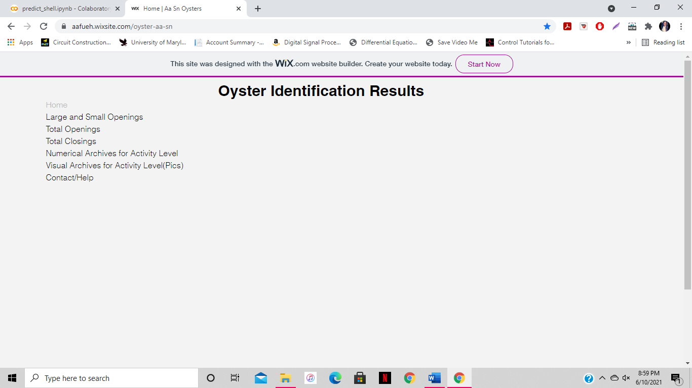

The second tab, “Large and Small Openings”, have two graphs. The first graph will tell you how many oysters in the trial had the position of a large opening, and the second graph will tell you how many oysters in the trial had a position of a small opening.

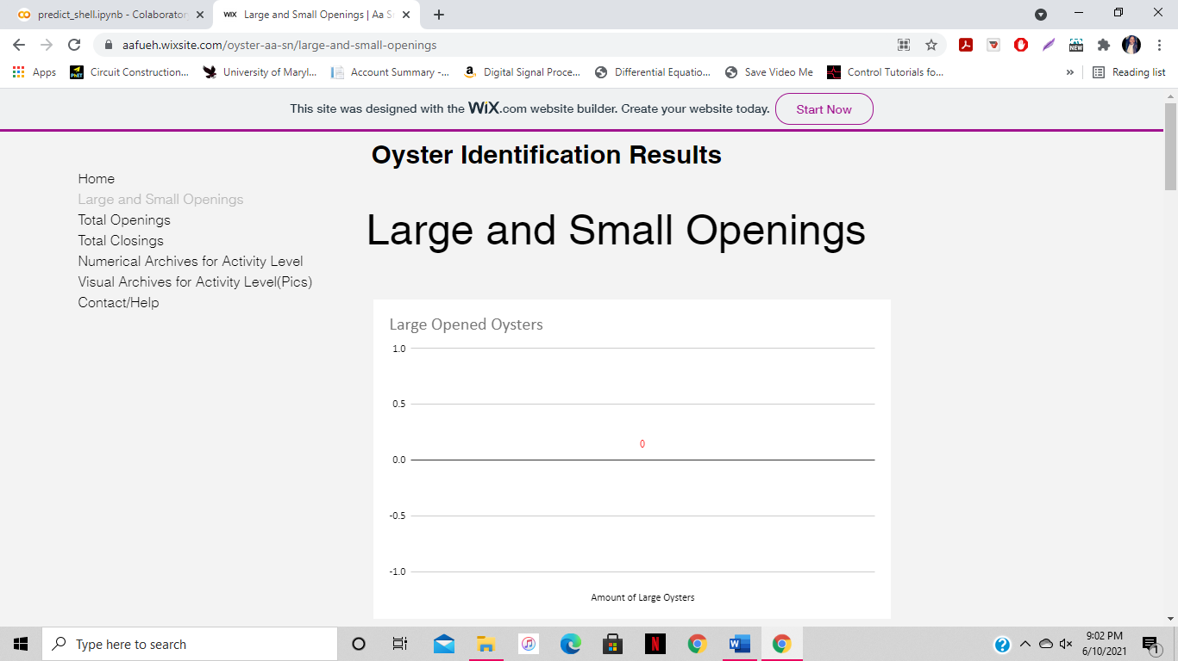 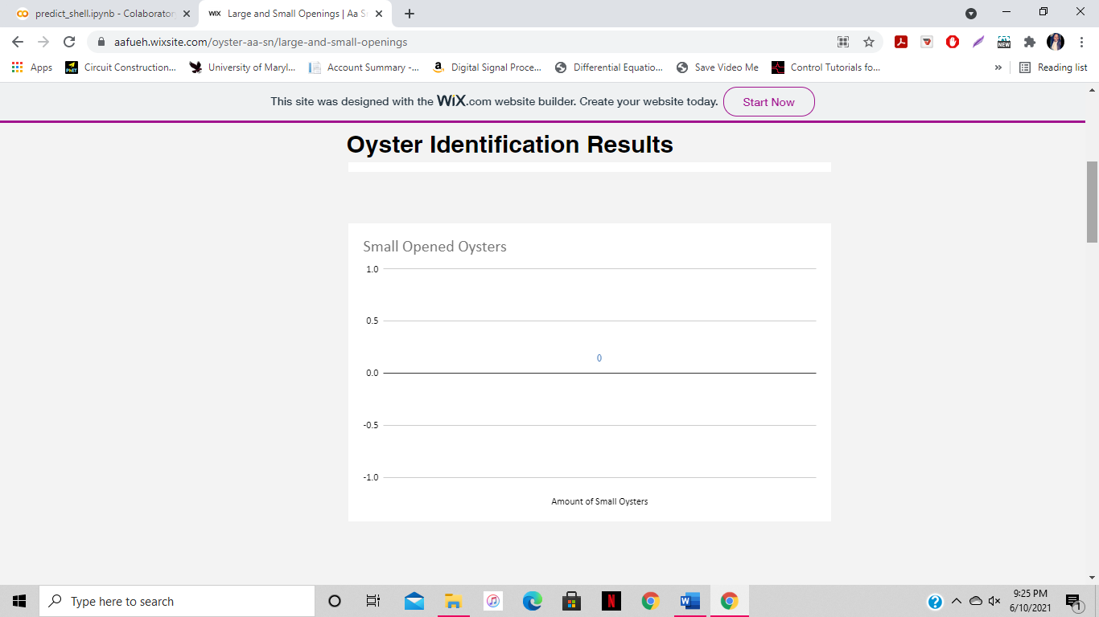

The third tab, “Total Openings”, has a graph that adds the large and small openings to depict the total number of oysters throughout the trial that were opened.

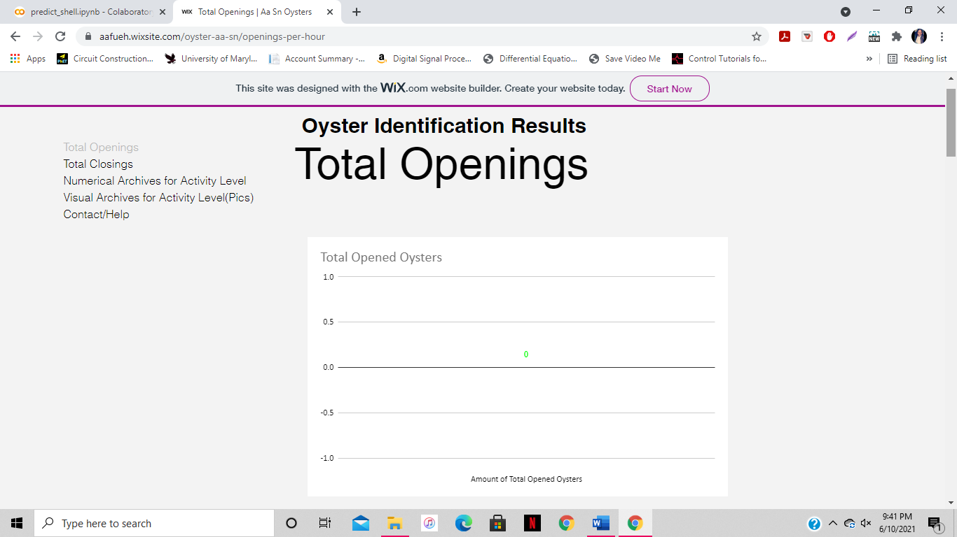

The fourth tab, “Total Openings”, has a graph that adds the large and small openings to depict the total number of oysters throughout the trial that were opened.

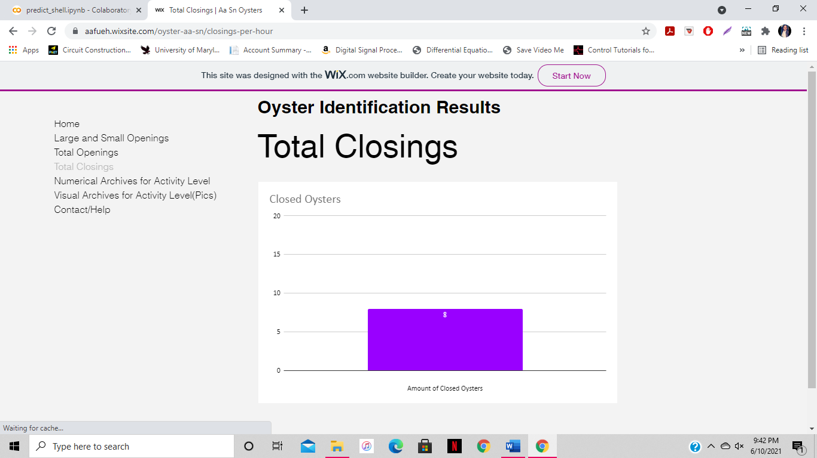

The fifth tab depicts the link for showing the labeled pictures after they undergo the image processing program. They will be viewable in google drive.

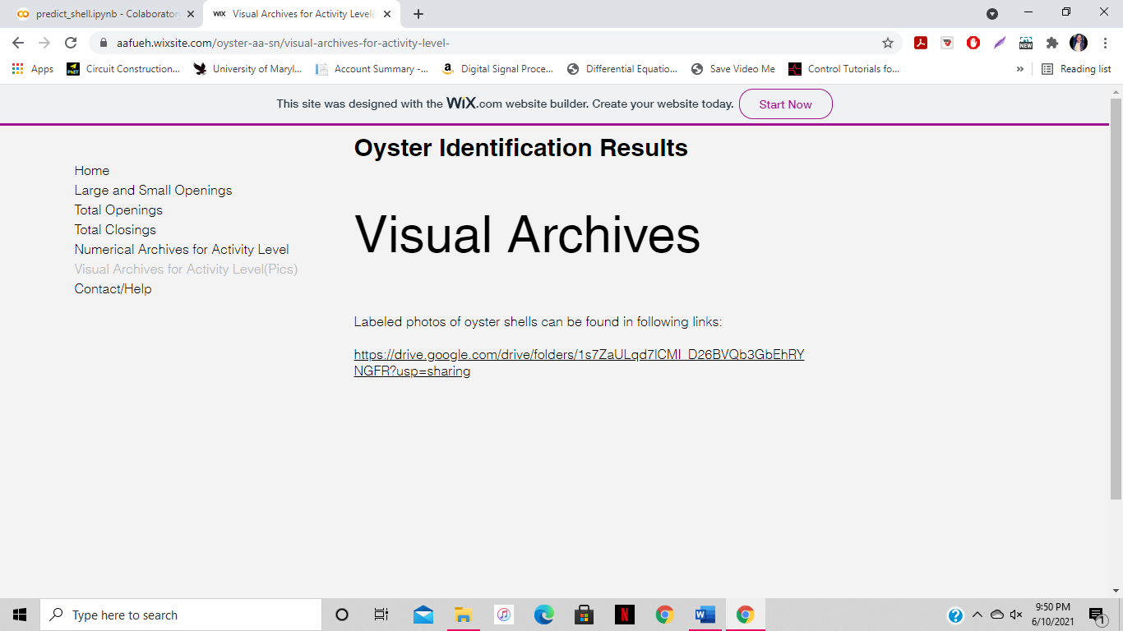

The sixth tab depicts the link for showing the numerical data of the oyster position identification after they undergo the image processing program. They will be viewable in google drive, via a spreadsheet. This spreadsheet will include the name of the picture, what position each picture identifies as, and the accuracy percentage for that identification.

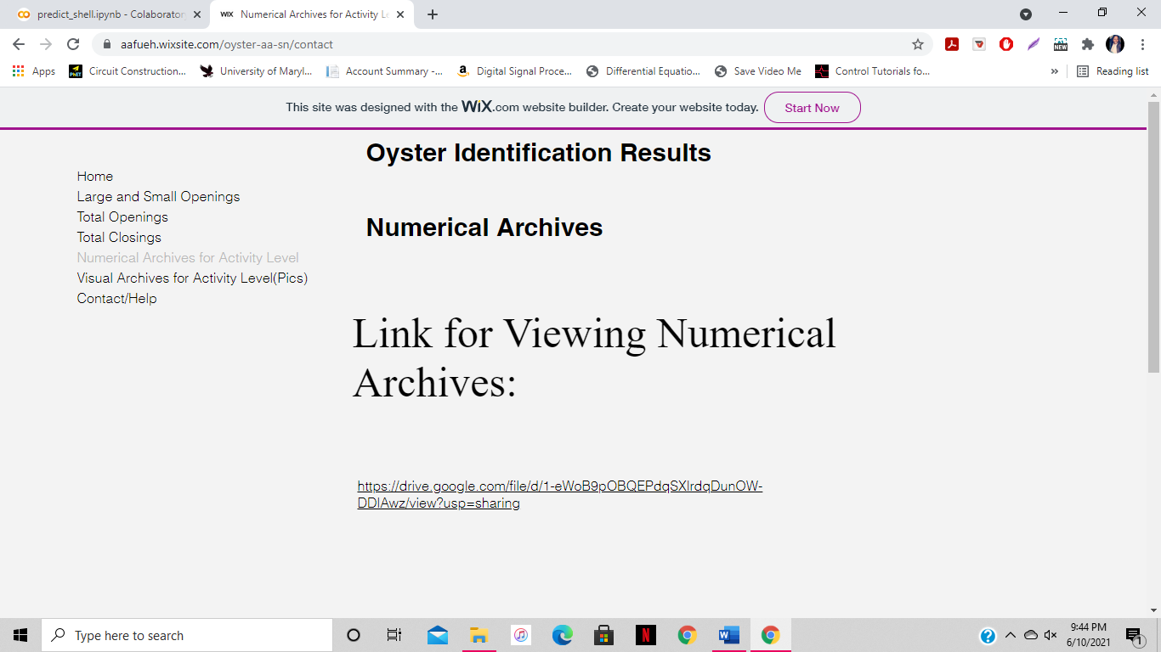

The seventh (and final) tab depicts the link for any questions, comments, or concerns the user might have about using the website. After submitting their name, email, and comment, the user will be responded to in 24-48 hours.

